Q) How to select features in a dataset for a machine learning project?

**Feature Selection is one of the core concepts in machine learning which hugely impacts the performance of your model.** The data features that you use to train your machine learning models have a huge influence on the performance you can achieve.

How to select features and what are Benefits of performing feature selection before modeling your data?

* **Reduces Overfitting**: Less redundant data means less opportunity to make decisions based on noise.
* **Improves Accuracy**: Less misleading data means modeling accuracy improves.
* **Reduces Training Time**: fewer data points reduce algorithm complexity and algorithms train faster.

Some of the methods are ➖

**1. Univariate Selection**

Statistical tests can be used to select those features that have the strongest relationship with the output variable. The scikit-learn library provides the SelectKBest class that can be used with a suite of different statistical tests to select a specific number of features. The example below uses the chi-squared (chi²) statistical test for non-negative features to select 10 of the best features from the Mobile Price Range Prediction Dataset.

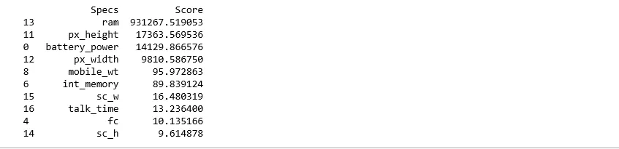

Here a strong correlation can be seen in various ram,px_height columns that can be considered as features in the model.

**2. Feature Importance**

You can get the feature importance of each feature of your dataset by using the feature importance property of the model. Feature importance gives you a score for each feature of your data, the higher the score, the more important or relevant is the feature towards your output variable. Feature importance is an inbuilt class that comes with Tree Based Classifiers, we will be using Extra Tree Classifier for extracting the top 10 features for the dataset.

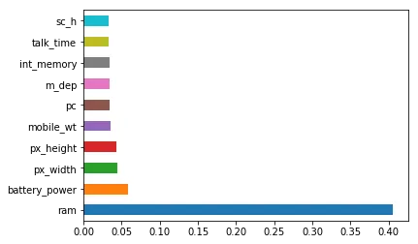

**3.Correlation Matrix with Heatmap Correlation**

It states how the features are related to each other or the target variable. Correlation can be positive (increase in one value of feature increases the value of the target variable) or negative (increase in one value of feature decreases the value of the target variable) Heatmap makes it easy to identify which features are most related to the target variable, we will plot heatmap of correlated features using the seaborn library.

Have a look at the last row i.e price range, see how the price range is correlated with other features, ram is the highly correlated with price range followed by battery power, pixel height and width while m_dep, clock_speed and n_cores seems to be least correlated with price_range.

